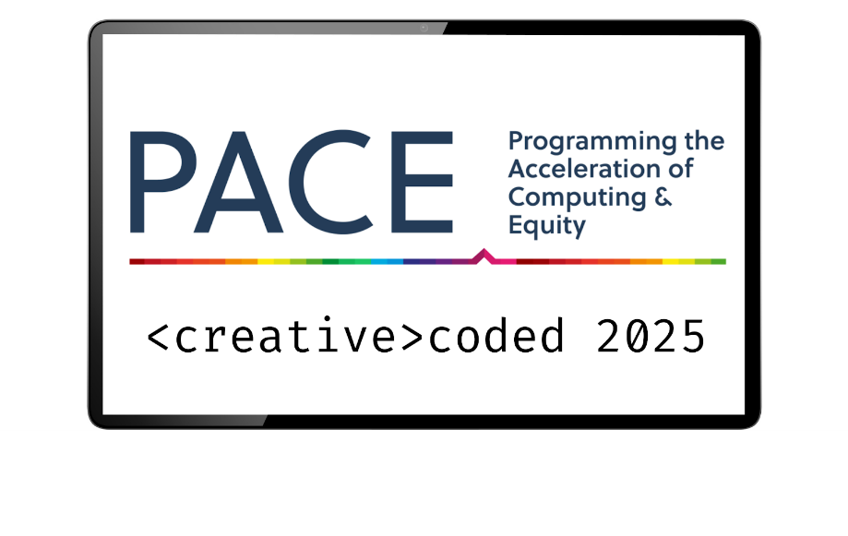

Coach/Reviewer Questions

The following is a list of questions to ask teams. Please make sure to ask a few questions directly to individual team members. Some students may be quieter than others and it is important to hear from everyone.

General Questions
- What are your names?
- What was the most fun part of doing your project?

Project Questions
- How did you decide what your project would be?
- How does your project reflect what you learned about in your CS class?
- Can you demo your project?

Poster Questions (if brought)
- Can you please explain your poster to me?
- How did you decide what to show on your poster?

Teamwork Questions
- What was your job on the team?
- Did you like working on a team?
- How did your teacher help you?

Award Descriptions and Criteria for Selection
Real-World Impact Award
Description:
The Real-World Impact Award is presented to the students and teams whose computer science projects have the greatest potential to solve real-world problems and make a meaningful difference in people’s lives. This award recognizes projects that go beyond creativity and technical skill, focusing on practical applications that address challenges in areas such as education, healthcare, environmental sustainability, accessibility, or community improvement.
Criteria for Selection:
- Addresses a real-world issue or societal need
- Demonstrates thoughtful problem-solving and innovation
- Shows potential for real-life application and usability
- Effectively communicates the impact of the project
This award celebrates young coders who use technology as a tool for positive change, inspiring them to continue exploring how computer science can improve the world!

Problem Solvers Award
Description:
The Problem Solvers Award is given to the students and teams that demonstrate exceptional critical thinking and troubleshooting skills in their computer science projects. This award recognizes those that effectively tackle challenges, overcome obstacles, and find innovative solutions to technical or real-world problems. Whether debugging complex code, optimizing performance, or designing a project that addresses a specific need, they showcase perseverance, creativity, and strong analytical thinking.
Criteria for Selection:
- Successfully identifies and solves challenges within their project
- Demonstrates resilience and adaptability in troubleshooting issues
- Applies logical thinking and creative problem-solving techniques
- Clearly explains the problem, the solution, and the process behind it
This award celebrates students who embrace challenges, think outside the box, and use computer science as a tool to solve problems effectively!

Bright Ideas Award
Description:
The Bright Ideas Award is presented to the students and teams with the most creative and innovative concepts in their computer science project. This award recognizes students who think outside the box, bringing fresh, imaginative ideas to technology and problem-solving. Whether it’s a unique approach to coding, a groundbreaking app, or a clever way to use technology to improve daily life, they demonstrate originality and forward-thinking.
Criteria for Selection:
- Displays creativity and originality in their project idea
- Introduces a unique or unexpected solution to a problem
- Shows potential for further development or future innovation
- Clearly communicates their idea and why it stands out
This award celebrates young innovators who bring bold, inventive ideas to life through computer science!

Creative Team Award
Description:
The Creative Team Award is given to the groups that showcases outstanding teamwork and originality in their computer science projects. This award recognizes teams that collaborate effectively while thinking outside the box, using their combined skills to create something truly unique. Whether through an innovative project idea, a visually engaging design, or an unexpected approach to problem-solving, this team demonstrates both creativity and strong cooperative spirit.
Criteria for Selection:
- Demonstrates excellent teamwork and collaboration
- Showcases originality and creativity in their project
- Effectively combines different skills and ideas within the team
- Presents their work in an engaging and imaginative way
This award celebrates teams that prove that great ideas come to life through creative collaboration!

Future Innovators Award
Description:
The Future Innovators Award is presented to the students and teams that demonstrate the greatest potential to shape the future of technology through their computer science projects. This award recognizes young minds who use creativity, problem-solving, and technical skills to develop forward-thinking solutions. Whether their project introduces a groundbreaking idea, improves an existing technology, or envisions a smarter future, this team showcases the spirit of innovation and discovery.
Criteria for Selection:
- Displays a forward-thinking and inventive approach
- Develops a project with potential for future growth or real-world impact
- Uses technology in an innovative and meaningful way
- Demonstrates curiosity, creativity, and problem-solving skills
This award celebrates the next generation of tech leaders who are paving the way for the future of innovation!

Time | Table | School/District | Team | Recommended Award | Reason for the Award
10:15 | 21 | Ware | Practice Can | - Real World Impact Award  - Problem Solvers Award  - Bright Ideas Award  - Creative Team Award  - Future Innovators Award
10:20 | 22 | Ware | Cloud Counter | - Real World Impact Award  - Problem Solvers Award  - Bright Ideas Award  - Creative Team Award  - Future Innovators Award
10:25 | 23 | Ware | Math Machine 3000 | - Real World Impact Award  - Problem Solvers Award  - Bright Ideas Award  - Creative Team Award  - Future Innovators Award
10:30 | 24 | Ware | Be quiet… | - Real World Impact Award  - Problem Solvers Award  - Bright Ideas Award  - Creative Team Award  - Future Innovators Award
10:40 | 6 | Hatfield | Propose an App | - Real World Impact Award  - Problem Solvers Award  - Bright Ideas Award  - Creative Team Award  - Future Innovators Award
10:45 | 7 | Hatfield | LED Greeting Cards | - Real World Impact Award  - Problem Solvers Award  - Bright Ideas Award  - Creative Team Award  - Future Innovators Award
10:50 | 8 | Hatfield | LED Greeting Cards | - Real World Impact Award  - Problem Solvers Award  - Bright Ideas Award  - Creative Team Award  - Future Innovators Award
10:55 | 9 | Hatfield | LED Greeting Cards | - Real World Impact Award  - Problem Solvers Award  - Bright Ideas Award  - Creative Team Award  - Future Innovators Award

